1. Instance Creation 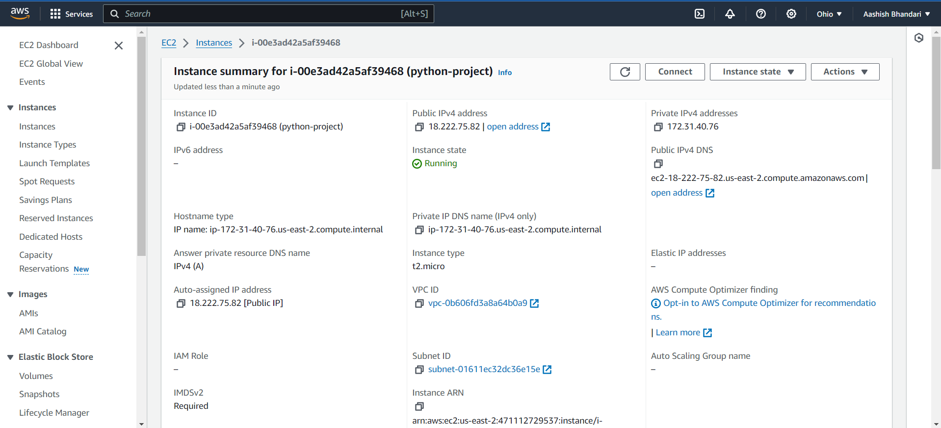
2. Created SnapshotA screenshot of a computer

   Description automatically generated
3. Updated policy for lamda function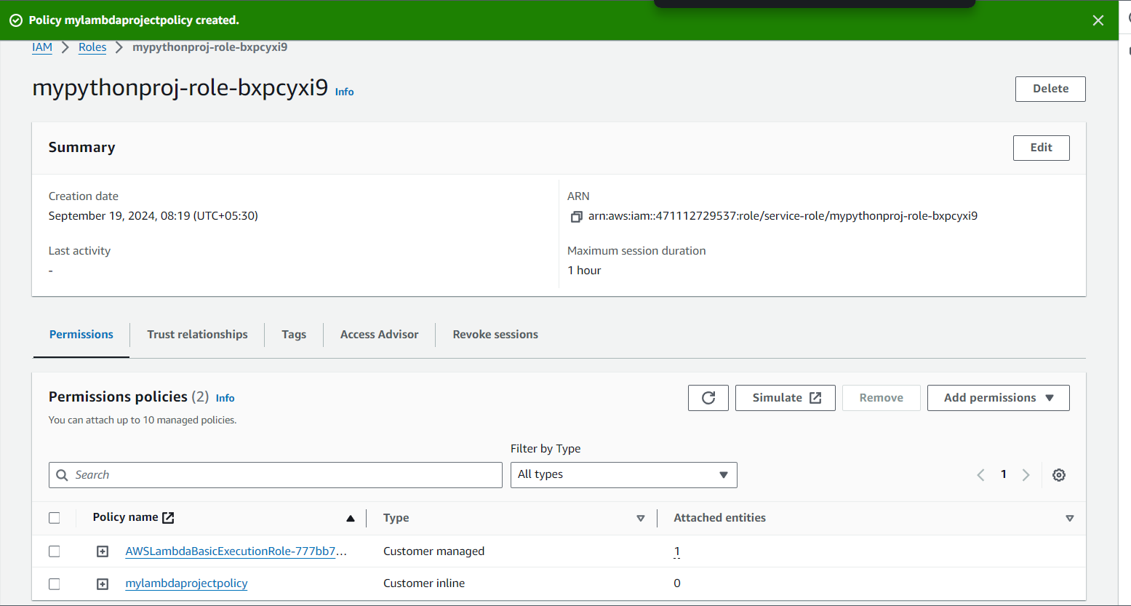
4. Uploaded CodeA screenshot of a computer

   Description automatically generated
5. Success will look like this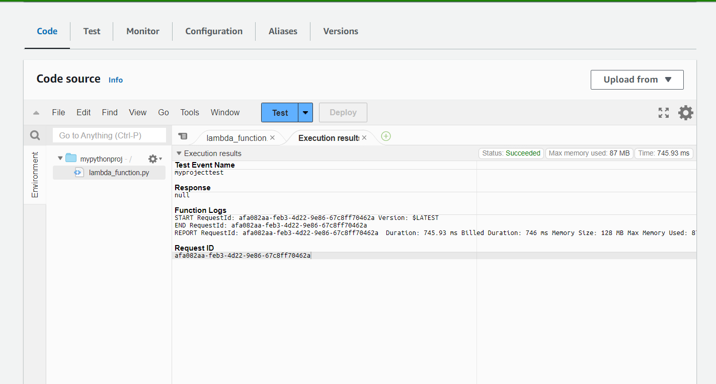
6. Now deleting the instance will delete the volumeA screenshot of a computer

   Description automatically generated
7. Adjusted the date and time in code and snapshot got deletedA screenshot of a computer

   Description automatically generated
8. Scheduling my lambda function A screenshot of a computer

   Description automatically generated
9. Event Scheduler is scheduledA screenshot of a computer

   Description automatically generated
10. IAM policiesA screenshot of a computer

    Description automatically generated

Trusted relationship

{

"Version": "2012-10-17",

"Statement": [

{

"Effect": "Allow",

"Principal": {

"Service": "events.amazonaws.com"

},

"Action": "sts:AssumeRole"

},

{

"Effect": "Allow",

"Principal": {

"Service": "scheduler.amazonaws.com"

},

"Action": "sts:AssumeRole"

}

]

}